EX.NO: 5
SQL Operators – BETWEEN, IN, LIKE, ORDER BY
AIM
To retrieve records from the MobileSales table using SQL operators such as BETWEEN, IN, LIKE, and ORDER BY.
PROCEDURE
- Select the MobileDB database using the USE command.
- Display all records from the MobileSales table.
- Retrieve records using the BETWEEN operator.
- Retrieve records using the IN operator.
- Retrieve records using the LIKE operator with pattern matching.
- Sort the records in ascending order using the ORDER BY clause.
- Sort the records in descending order using the ORDER BY clause.
- Observe the output of each query.
- Verify that the SQL operators retrieve and sort the required records correctly.

COMMANDS
1. Select the Database
USE MobileDB;
2. Display All Records
SELECT * FROM MobileSales;
3. BETWEEN Operator
Display mobiles with price between ₹25,000 and ₹50,000.
SELECT * FROM MobileSales
WHERE Price BETWEEN 25000 AND 50000;
4. IN Operator
Display mobiles released in 2024 or 2025.
SELECT * FROM MobileSales
WHERE ModelYear IN (2024, 2025);
5. LIKE Operator
Display mobiles whose names start with 'i'.
SELECT * FROM MobileSales
WHERE MobileName LIKE 'i%';
6. LIKE Operator
Display mobiles whose names end with '12'.
SELECT * FROM MobileSales
WHERE MobileName LIKE '%12';
7. ORDER BY
Sort mobiles by Price in ascending order.
SELECT * FROM MobileSales
ORDER BY Price ASC;
8. ORDER BY (Descending)
Sort mobiles by CustomerReview in descending order.
SELECT * FROM MobileSales
ORDER BY CustomerReview DESC;

OUTPUTS
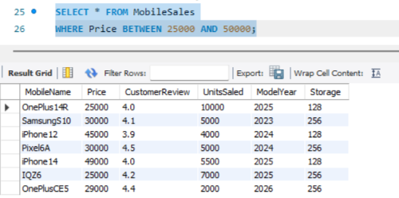
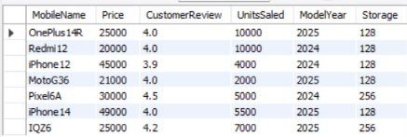

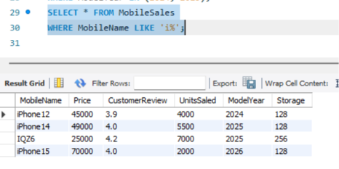

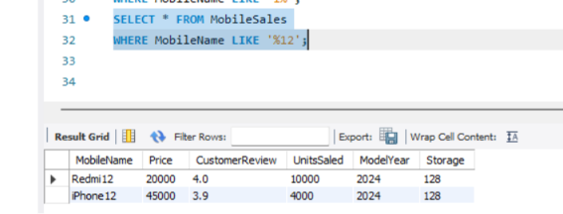

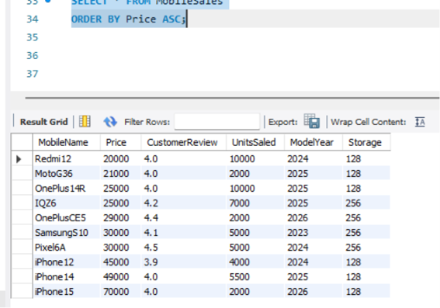
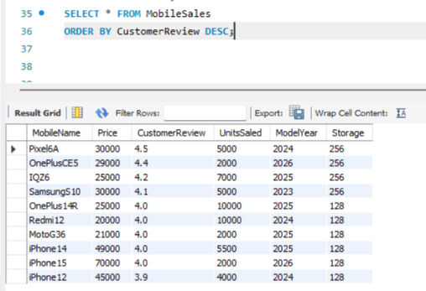

RESULT
Thus, the SQL operators (BETWEEN, IN, LIKE, and ORDER BY) were successfully executed on the MobileSales table, and the required records were retrieved and sorted successfully.

